Therapy for Horse & Rider

Acupuncture

The acupressure and the acupuncture originate from China and were introduced to the Western World only in the last century. The diagnostic and healing powers of using the hands (acupressure) or by means of metal needles of different lengths (Acupuncture) as a form of therapy has long been recognized as serious. Through the stimulation of certain areas (Accupoints), a diagnosis of malfunctions und illnesses can be found. Pain can be linderd and certain processes in the body can be triggered. Blockages can be freed; individual organ may be stimulated or calmed. The accupoints can be found within certain meridians, which traverse the complete body and are energized (Chi). All meridians are correlated to individual organs within the body. Besides the well known ear acupuncture, where certain areas correlate to specific organs, there are also different acupuncture forms that amplify the stimulus, such as the Electro puncture and the Moxibustion (warmth therapy). In the case of laser acupressure, a laser is used instead of needles.

Different Forms of Therapy

Pain therapy (specifically back and limb and the resulting partial paralysis), blockages, organ dysfunctions and energetic misbalances can be cured or (at the very least) minimized. As a prophylactic, illnesses may be circumvented, natural body immune defense amplified and the general well being secured. Organ and body dysfunctions can be normalized, major and chronic illnesses may be stabilized. Prerequisite for this is that no mechanical blockages, destroyed body structures or operative processes are forthcoming. In combination with school medicine, acupuncture is also used for infections, post operative care or rehabilitation. Continuation of care can be done by the owner of the horse (after consulting the veterinarian).

Stream Blossom Therapy

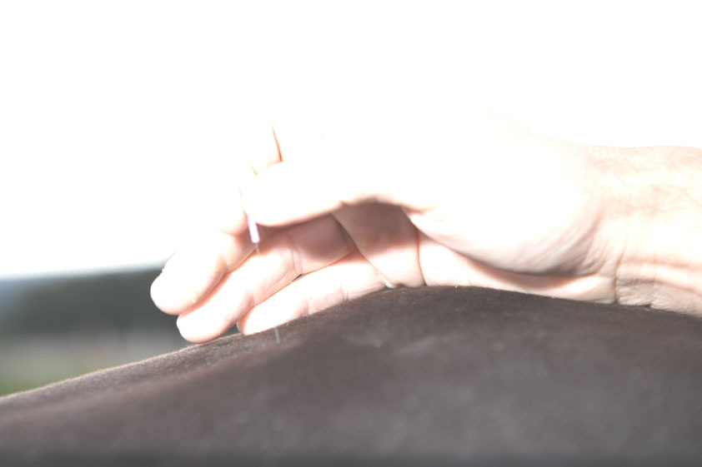
The SBT is a united therapy to bring the body and soul together. The SBT consists of blossom essences stemming from 38 wild, non-poisonous flowers, bushes and trees and a remedy that consists of the combined essences of five flowers (so called Rescue Therapy).

Magnetic Field Therapy

The MFT is one of the oldest healing methods. As a therapy, magnetic fields are used, to activate natural self healing processes within the patient’s body. The main achievement is to stabilize the energetic state of the horse’s body. A cell has an electrical potential, which is used to transports chemicals. If this potential is changed, the cell cannot continue its original function at 100%, leading to a higher possibility of infections allergens. In a worst case scenario, the cell dies off. Should larger areas of cells die off, a high risk of degeneration of tissue occurs. Through the swinging waves of the magnet, the energetic flows within the cells are stabilized and the flow of oxygen in the area of treatment is restored, leading to the cells being able to regenerate themselves. This therapy may be used in conjunction with other therapies, as it has no side effects.
The MFT is used to regenerate blood flow, healing of wounds and chemical exchanges within the skeletal movement areas and within soft tissue areas. Prerequisite are no mechanical blockages and all body structures are in place. Malfunctions can be cleared, destroyed tissue cannot be restored.

Osteopathy

As with the method of chiropractic, the osteopathy deals with the knowledge of bones and joints, especially the spinal cord. A strong knowledge of anatomy is needed. With the help of special movement and grip techniques, bones and the spinal cord are brought back into their correct anatomical positions. This method has proven to be successful if anatomical abnormalities or similar issues are present.

Physiotherapy

This therapy comprises the usage of hands and physical methods, such as electric current, magnetic fields, ultrasound, laser, cold and heat therapies and water exercise. Physiotherapy is used in the healing, prevention and rehabilitation of illnesses. Hands are used to introduce certain stretch and massage techniques, in order to stimulate bodily reflexes and provide relief to muscles. This therapy is especially useful for preventing illness, injuries and muscle tensions. The horse’s performance is enhanced, lymph drainage is invigorated and movement is more fluid.

BICOM

The BICOM Bio-Resonance Method is a special diagnostic and therapy, in which a new and successful way in medicine is taken.
The BICOM can actually find the true and often hidden causes for illnesses. The Bio-Resonance Method is a so called soft form of therapy that involves no medication.

